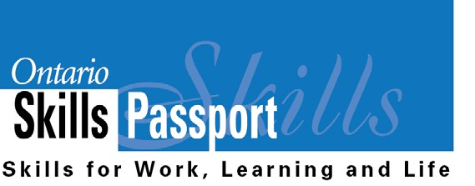

My Essential Skills - Primary
Individual Assignment
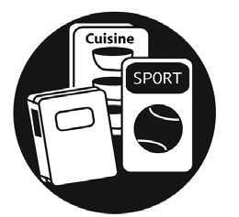
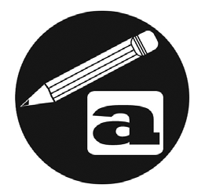
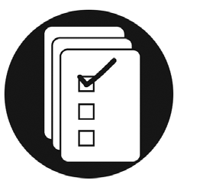
I am someone who...

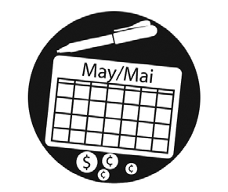
Loves looking at pictures and reading words I know in books!
Loves to write (e.g., name, pictures, notes, stories)!
Can read signs in my community.

Can login and use a mouse on a computer.
Knows the names of coins and
how much they are worth.
Can read my class schedule and plan when I need to study for a quiz.

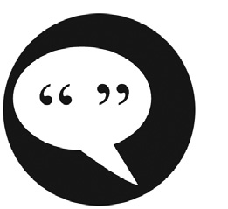
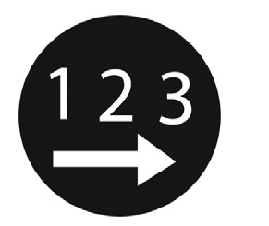
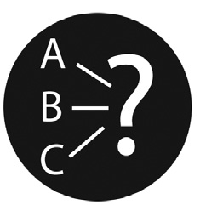
Can figure out how many plates and cups I need to set a table for my family.
Can judge if I have the appropriate art supplies to complete a project.
Can guess how many scoopfuls of sand I need to fill my pail.

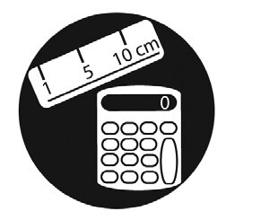
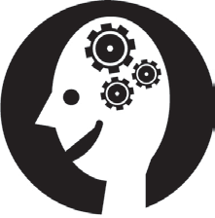
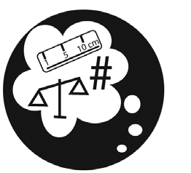
Can ask a friend or an adult for something I need.
Can pack my backpack with the
things I need for school.
Can make choices about what clothing I will wear based on the weather forecast.

Loves doing puzzles and solving riddles!
Can ask an adult to help me find something (e.g., washroom or drinking fountain).
Can compare my marks on two assignments to determine whether my skills are improving.

